[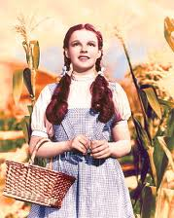](http://www.google.com/imgres?q=dorothy+wizard+of+oz&hl=en&biw=1280&bih=895&tbm=isch&tbnid=M0p-h4eFpPxvtM:&imgrefurl=http://gremlindog.com/lists/a-guide-to-sexy-halloween-costumes-guys-youre-welcome/&docid=d1YQDHUD273I5M&imgurl=http://gremlindog.com/wordpress/wp-content/uploads/2008/10/dorothy2.jpg&w=224&h=280&ei=cHsXT_WIAavXiAKr-oHyDw&zoom=1)

Draw a picture of Dorothy

These are words that describe Dorothy

[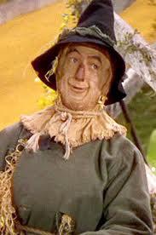](http://www.google.com/imgres?q=scarecrow+wizard+of+oz&hl=en&biw=1280&bih=895&tbm=isch&tbnid=JawNpX0lDlBafM:&imgrefurl=http://blogs.coventrytelegraph.net/fromdawntillrusk/2011/03/scarecrow-in-the-spotlight.html&docid=QSPoCo-lrQqKhM&imgurl=http://blogs.coventrytelegraph.net/fromdawntillrusk/Wizard%20of%20Oz%20scarecrow.jpg&w=300&h=452&ei=w4AXT-y6MuXW2AXjjZ24Ag&zoom=1)

Draw a picture of the Scarecrow

These are words that describe the Scarecrow

[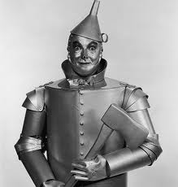](http://www.google.com/imgres?q=tin+man+wizard+of+oz&hl=en&biw=1280&bih=895&tbm=isch&tbnid=HehSG0WW2U3SKM:&imgrefurl=http://www.andrewgarvey.com/wizard/characters/TheTinManProfile.html&docid=obywqU3eFqNLaM&imgurl=http://www.andrewgarvey.com/wizard/characters/Images/The%20Tin%20Man%201.jpg&w=430&h=450&ei=GIEXT5O2FoH82gWVo7y4Ag&zoom=1)[](http://www.google.com/imgres?q=Wicked+Witch+wizard+of+oz&hl=en&biw=1280&bih=895&tbm=isch&tbnid=BUiVzvBiEsNzJM:&imgrefurl=http://vintagegal.tumblr.com/post/14119960597/the-wizard-of-oz-1939&docid=l2Z9ZuIvOZcwuM&imgurl=http://www.tumblr.com/photo/1280/14119960597/1/tumblr_lw30rwwPa51qa70ey&w=1280&h=935&ei=-4EXT8qWHaqG2gXmtZi4Ag&zoom=1)

Draw a picture of the Tin Woodman

These are words that describe the Tin Woodman

Draw a picture of the Wicked Witch

These are words that describe the Wicked Witch

[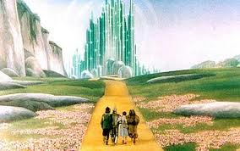](http://www.google.com/imgres?q=the+wizard+of+oz&hl=en&biw=1280&bih=895&tbm=isch&tbnid=hOufez7q-zbfTM:&imgrefurl=http://www.telegraph.co.uk/culture/film/classic-movies/8025216/Wizard-of-Oz-Why-is-Andrew-Lloyd-Webber-setting-out-on-the-Yellow-Brick-Road.html&docid=07nqELoUaunoVM&imgurl=http://i.telegraph.co.uk/multimedia/archive/01682/wizard_1682401c.jpg&w=460&h=288&ei=zYcXT8PbKZSisQK8q5yzAg&zoom=1)[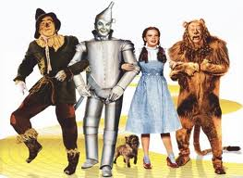](http://www.google.com/imgres?q=the+wizard+of+oz&hl=en&biw=1280&bih=895&tbm=isch&tbnid=e5tlILFBjOsiEM:&imgrefurl=http://lydiamusic.com/wizard-of-oz-tickets.html&docid=-MjDhMfjDdfweM&imgurl=http://lydiamusic.com/wp-content/uploads/2010/05/wizard-of-oz.jpg&w=475&h=347&ei=zYcXT8PbKZSisQK8q5yzAg&zoom=1)[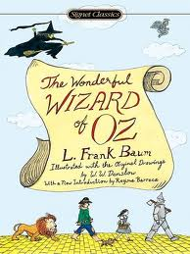](http://www.google.com/imgres?q=The+wonderful+wizard+of+oz+cover+by+frank+baum&hl=en&biw=1280&bih=895&tbm=isch&tbnid=xMa8Kly4ivuvrM:&imgrefurl=http://ebookstore.sony.com/ebook/l-frank-baum/the-wonderful-wizard-of-oz/_/R-400000000000000164268&docid=LiVaHp4DP0bUfM&imgurl=http://ebooks-imgs.connect.com/product/400/000/000/000/000/164/268/400000000000000164268_s4.jpg&w=375&h=500&ei=4oYXT9ToJeXjsQKmoqimAg&zoom=1)

Name: __________________

Setting

Characters

Chapter ____

This is what happened in the story today…

[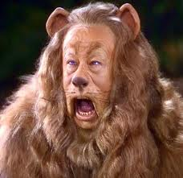](http://www.google.com/imgres?q=lion+wizard+of+oz&hl=en&biw=1280&bih=895&tbm=isch&tbnid=DYC6CEVt6e4aCM:&imgrefurl=http://arunmanansingh.wordpress.com/2009/08/19/cowardly-lion/cowardlylion/&docid=qwAU-8kRXAYr7M&imgurl=http://arunmanansingh.files.wordpress.com/2009/08/cowardlylion.jpg?w=496&w=496&h=481&ei=5IIXT5WdMuz4sQKB2-SYAg&zoom=1)

These are words that describe the Lion

Draw a picture of the Lion